**Power BI Assignment 4**

--------------------------------------------------------------------------------------------------------------------------------------

Q1:- Make a simple dashboard and show columns, bar charts, line charts, and area charts.

Ans:-

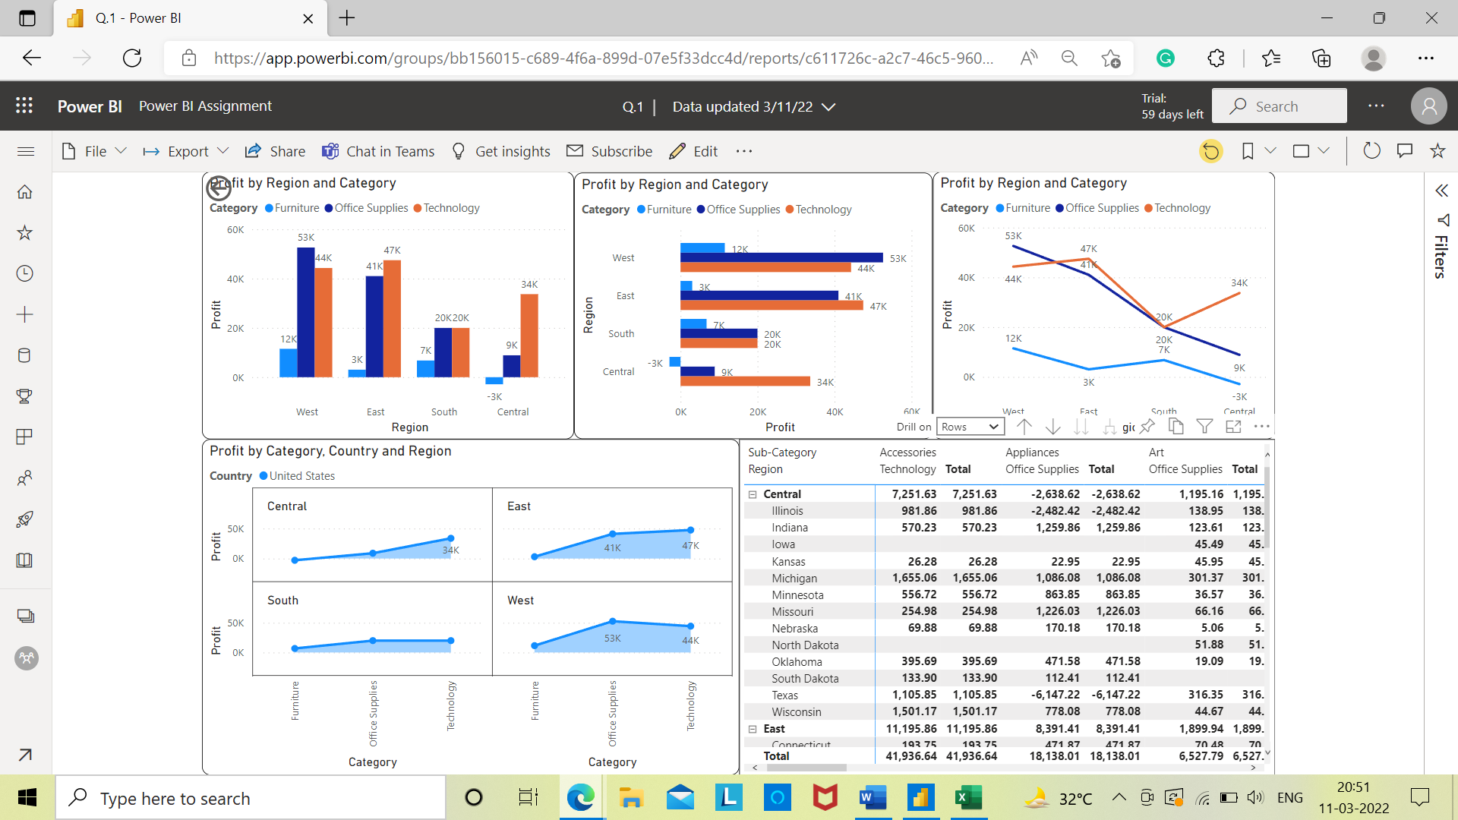

--------------------------------------------------------------------------------------------------------------------------------------

Q2:- Make a simple dashboard and show combination chart, Scatter chart, Shape chart, and Treemap chart.

Ans:-

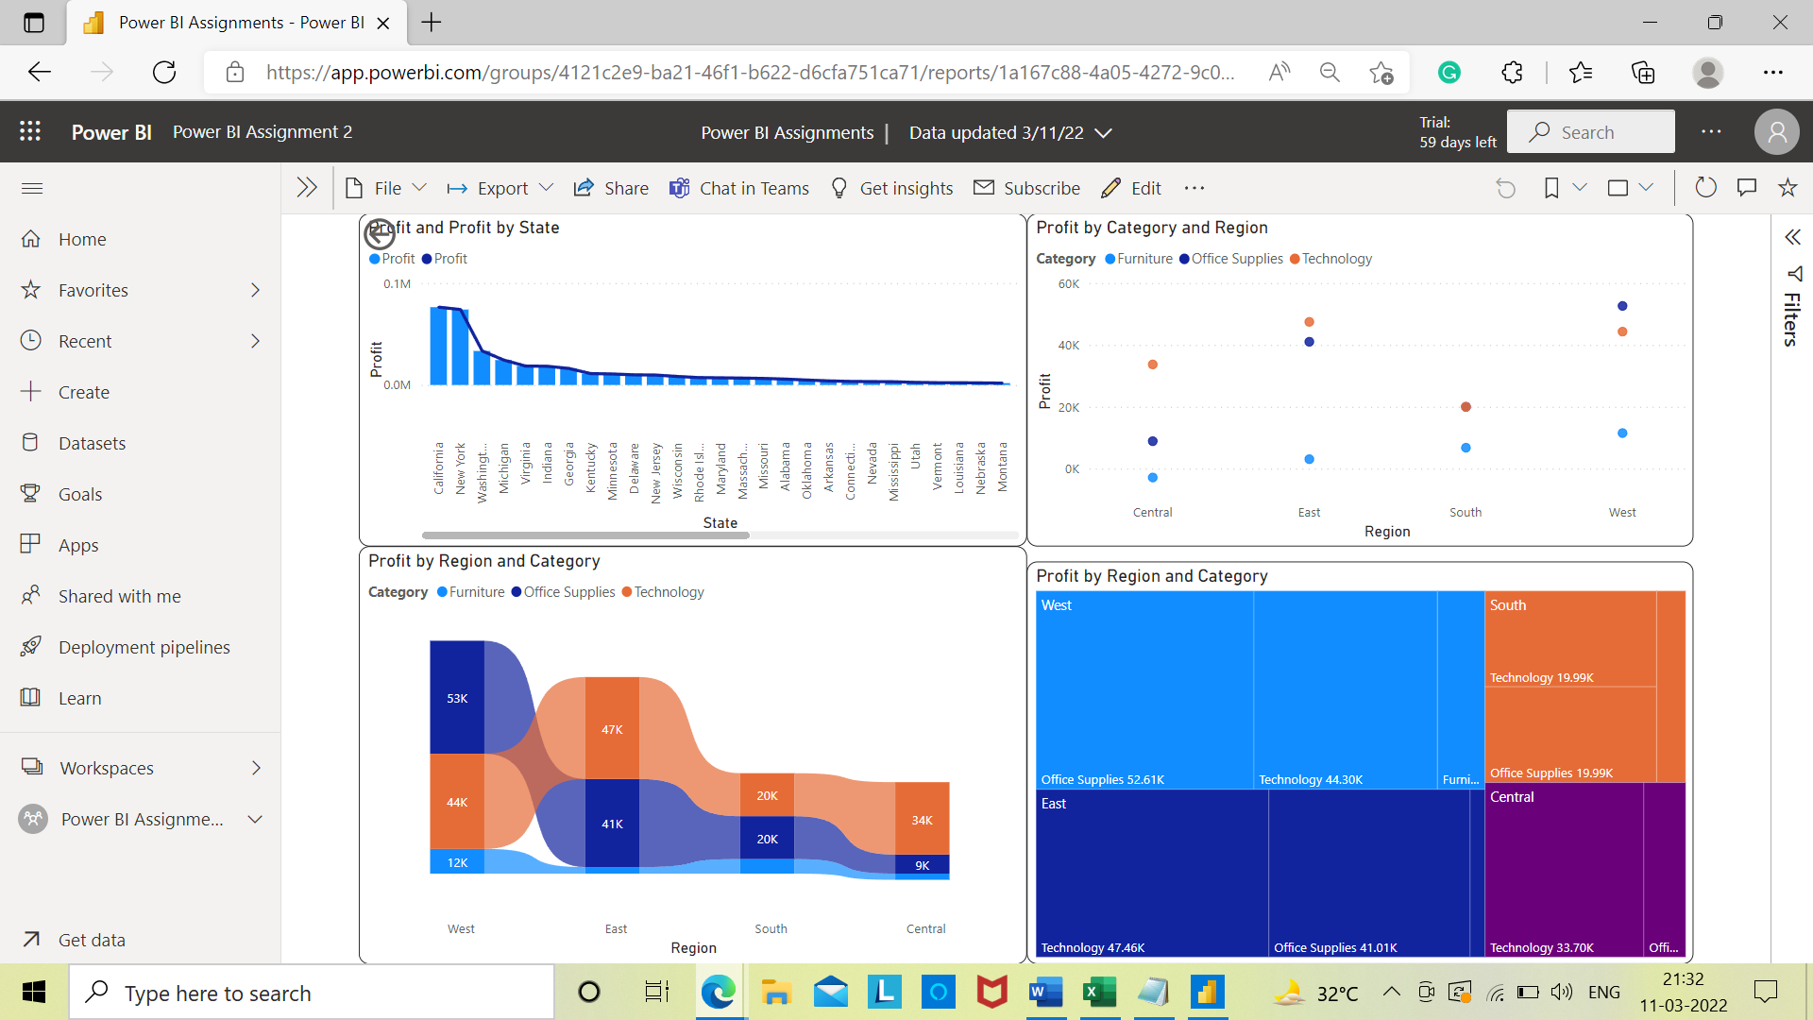

--------------------------------------------------------------------------------------------------------------------------------------

Q3:- Make a dashboard and show 2 maps visualization i.e. basic map and filler maps.

Ans**:- “Filler Map” “Basic Map”**

“ 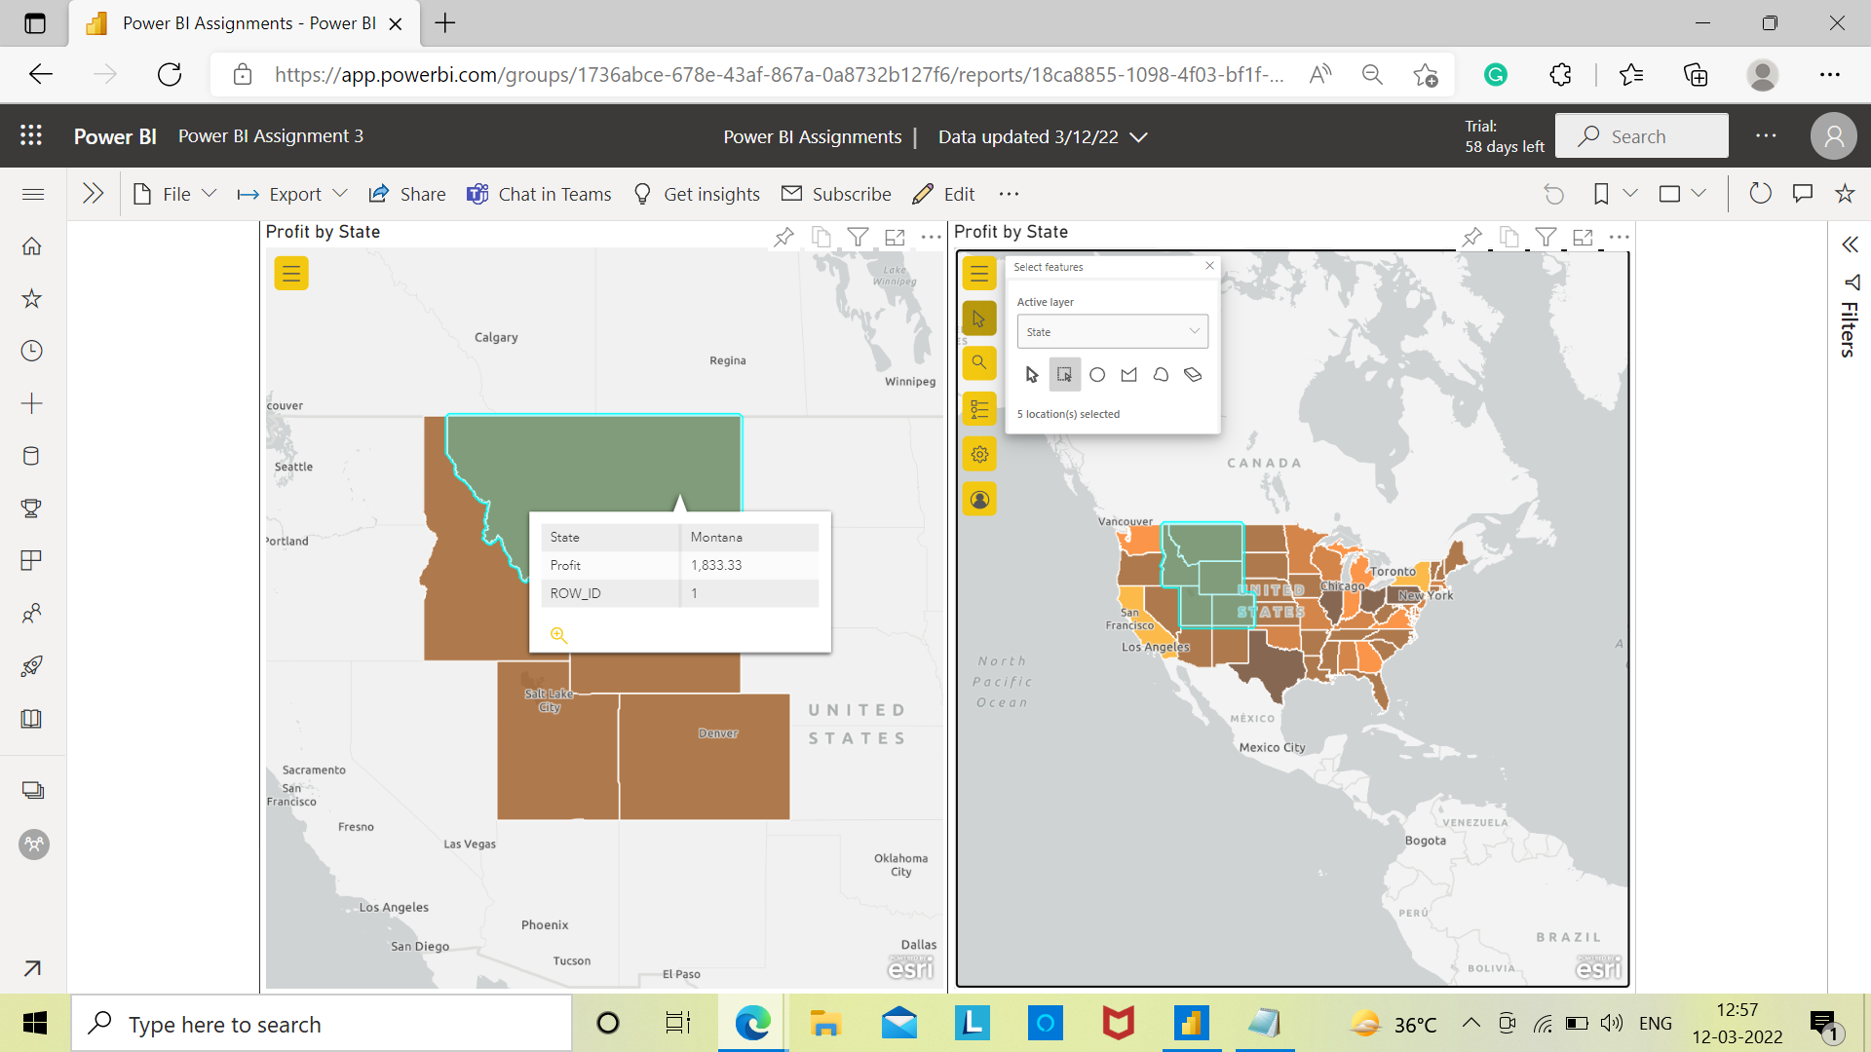--------------------------------------------------------------------------------------------------------------------------------------

Q4:- Create a report which has:

Bar chart

Card visualizations

Combo chart visualizations

Matrix visualizations

Column chart visualizations

guide: Sales data can be used

Ans:-

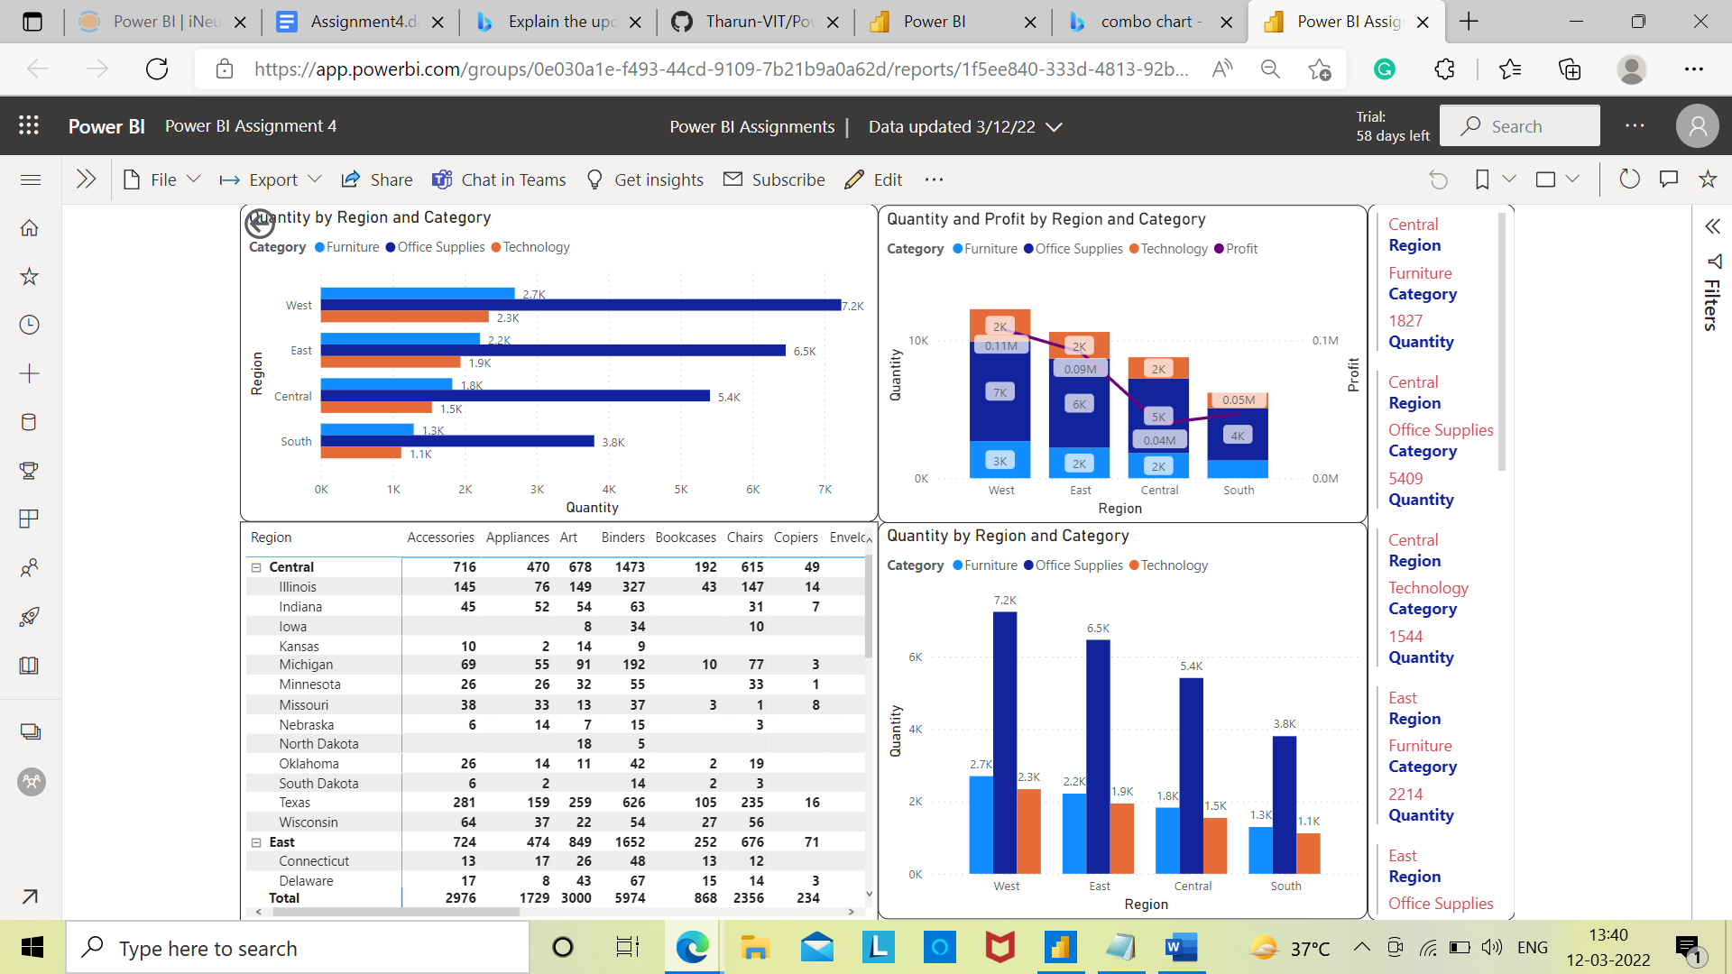

--------------------------------------------------------------------------------------------------------------------------------------

Q5:- Make a report to analyze product sales using treemap visualization.

Ans:-

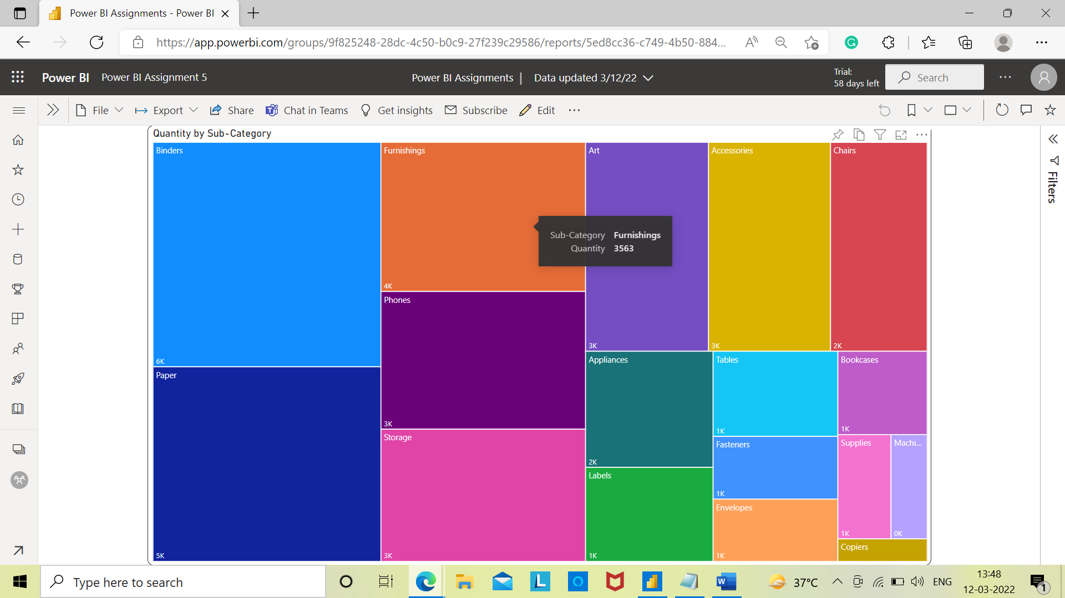

--------------------------------------------------------------------------------------------------------------------------------------

Q6:- Make a dashboard on sales data (Minimum 4 tiles).

Ans:-



